Contributor: Deborah Caplow

**The Taller de Gráfica Popular**

**(TGP, Popular (or People’s Graphic Workshop)**

The TGP was founded in Mexico City in 1937 and although it is still in existence at present, it maintained its original form until the end of the 1950s, which will be the period focused on here. The TGP was primarily a workshop for graphic art, and produced thousands of handmade prints and posters. Images by artists of the TGP are distinguished by their sympathetic depictions of Mexican workers, their portrayals of Mexican life and history, and their focus on the effects of fascism and Nazism both in Mexico and in Europe. The TGP played a dynamic role in the development of a Mexican political art movement and a modern Mexican cultural identity. Based in Mexico City, the TGP was the foremost centre for the production of political graphics for more than two decades. Founded by artists **Leopoldo Méndez**, Pablo O’Higgins, Raúl Anguiano and Luís Arenal in 1937, the TGP grew to a membership of about twenty-five artists who worked collectively to produce political prints for a variety of leftist causes. They focused on both domestic and international events, and formed strong ties with artists in many other countries.

In the 1930s, artists in Mexico established two significant arts organisations: the Liga de Escritores e Artistas Revolucionarios (LEAR, League of Revolutionary Artists and Writers), in 1934, and the TGP. The TGP founders were joined by Angel Bracho and Alfredo Zalce, Isidoro Ocampo, José Chávez Morado, Xavier Guerrero, Francisco Dosamantes, Ignacio Aguirre and Francisco Mora. At its height the TGP had a fluctuating membership of about twenty-five Mexican artists and attracted guest artists from around the world; some of them stayed on, like Mariana Yampolsky and **Elizabeth Catlett**. They admired printmaker **José Guadalupe Posada** and the Mexican muralists, as well as artists such as Francisco Goya, Honoré Daumier and **Käthe Kollwitz**, and were influenced by **Russian Constructivism**, **German Expressionism, and Surrealism**. The TGP produced posters, pamphlets, portfolios and books, using lithograph, woodblock and linoleum techniques. They pasted prints on walls and lampposts, and provided them for demonstrations. TGP prints were often ephemeral works produced for specific events and widely disseminated, though they also made fine art versions on high-quality paper.

One of Taller’s first projects was a series of eighteen large-scale lithographic posters for anti-Nazi lectures at the Palacio de Bellas Artes (Palace of Fine Arts), sponsored by the Liga Pro-Cultura Alemana (League for German Culture) in 1938 and 1939. Covering a range of topics and styles, they were printed in runs of 2,000 and posted on the walls of Mexico City. The influence of German artist **John Heartfield** can be seen in two of O’Higgins’s prints, and Méndez’s contribution has Surrealist overtones. A poster by Pujol and Arenal shows affinities to the work of Spanish photomontage artist Josep Renau, who was in Mexico working with **David Alfaro Siqueiros** on the mural *Portrait of the Bourgeoisie*.

In the 1930s the TGP also made prints supporting the policies of the government of Lázaro Cárdenas. In 1942, architect Hannes Meyer, former director of the **Bauhaus,** began to work with the group, arranging for them to contribute numerous prints to the 1943 *El libro negro del terror nazi en Europa* (The Black Book of Nazi Terror in Europe), published by Germans in exile, the only systematic study of German attacks on European countries. Méndez’s *Deportación a la Muerte* (*Deportation to Death*), included in the book, is one of the earliest artistic images of the Holocaust, depicting a train taking Jewish prisoners to a concentration camp. Meyer also helped the group establish a press, La Estampa Mexicana (The Mexican Print), which published books and portfolios, among them *Incidentes melódicos del mundo irracional* (Melodic Incidents of an Irrational World, of 1944), a folktale written by Juan de la Cabada with illustrations by Méndez.

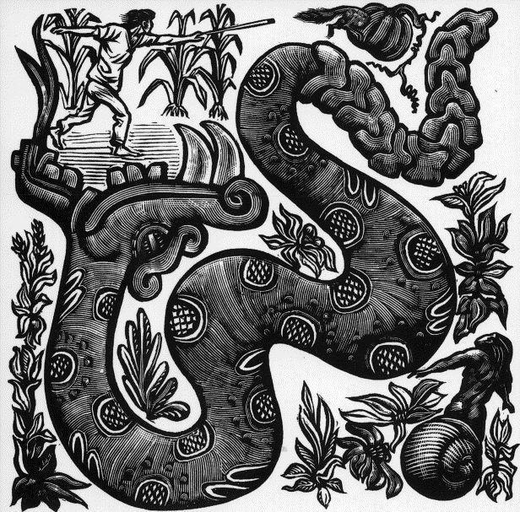

Leopoldo Méndez, *Serpiente cascabel* (Rattlesnake), from *Incidentes melódicos del mundo irracional*, wood engraving, 1944 (copyright Pablo Méndez)

http://www.artexpertswebsite.com/pages/artists/artists_l-z/mendez/4.snake-mexican-pos690x783.jpg

In the mid-1940s, younger artists joined the TGP, among them Alberto Beltrán, Arturo García Bustos, Francisco Mora, Andrea Gómez, Elizabeth Catlett and Mariana Yampolsky, and the TGP entered a new phase. Beltrán’s 1951 *Detengamos la guerra* (Let Us Stop the War) refers to the Cold War and the nuclear threat.

In 1947 the TGP produced *Estampas de la revolución mexicana* (*Prints of the Mexican Revolution*), eighty-five prints about the Revolution, and in 1960 published its last major project, *450 años de lucha: homenaje al pueblo mexicano* (450 Years of Struggle: Homage to the Mexican People), a set of 146 prints. During the 1950s the Taller continued to produce prints and held numerous exhibitions, in Mexico and abroad, but political and personal differences divided the group, and many artists left at the end of the 1950s. The TGP continued to exist, but in a reduced form. Its legacy remains strong in Mexico and the TGP continues to inspire contemporary political printmakers.

**Further Reading**

Ades, D. (2009) *Revolution on Paper: Mexican Prints*, 1910-1960. Austin: University of Texas Press.

Caplow, D. (2007) *Leopoldo Méndez: Revolutionary Art and the Mexican Print*. Austin: University of Texas Press.

Green, J. (1992) “Mexico's Taller de Gráfica Popular,” parts 1 and 2. *Latin American Art* 4 (3), 65-67; and 4 (4) 85-87.

Ittman, J. (2007) *Mexico and Modern Printmaking: a Revolution in the Graphic Arts, 1920 to 1950*. New Haven: Yale University Press.

Meyer, H., ed. (1949) *TGP México: El Taller de Gráfica Popular: doce años de obra artística colectiva/The Workshop for Popular Graphic Art: a record of twelve years of collective work*. Mexico City: La Estampa Mexicana.

Prignitz-Poda, H. (1992) *El Taller de Gráfica Popular en México, 1937-1977.* Mexico City: INBA-CENIDIAP.

Richards, S. (2001) “Imaging the Political: El Taller de Gráfica Popular in Mexico, 1937-1949.” Dissertation, University of New Mexico.

Tibol, R. “20 años de vida del Taller de Gráfica Popular.” *Artes de México* (Mexico City), no. 18 (July-August 1957): pp. 3-14.

**Artistic works by:**

Alberto Beltrán, *Detengamos la guerra* (Let Us Stop the War), 1951, linocut.

José Chávez Morado, El clero y la prensa (The Clergy and the Press), 1939, lithograph.

Leopoldo Méndez, *Deportación a la Muerte* (*Deportation to Death*), 1943, linocut.

Leopoldo Méndez, *Serpiente cascabel* (Rattlesnake), from *Incidentes melódicos del mundo irracional*, 1944, wood engraving.

Pablo O’Higgins, *Franco*, 1938, lithograph.

Antonio Pujol and Luís Arenal, *El fascismo* (Fascism),1939, lithograph.

Mariana Yampolsky, La bomba atómica (The Atomic Bomb), 1954, linocut.

Alfredo Zalce, *Chóferes contra las “Camisas Doradas” en el Zócalo de la Ciudad de México, 20 de noviembre de 1935* (*Taxi Drivers against the Gold Shirts in the Zocalo of Mexico City, 20 November, 1935*), 1940s, linocut.